FREE HONGXIN! He is innocent!
Pastor Chui, being a volunteer pastor for the New Life Gospel Christian Church for over four years, now volunteers for the case to free Hongxin. He is innocent!
Sister Liu, Hongxin's mother, has been my student in the California International Theological Seminary for several years now. She needs sympathy and support. Please help her.
I have reviewed Hongxin from his childhood to the present. He has been unfortunate to have an unstable and abusive wife who suffered from mental disorders and frequently acted up. After venting her anger, she was remorseful and apologizing. Finally, she passed away under unusual circumstances. According to Dr. Comparini's medical opinion, Hongxin's wife suffered from "gestational hypotension type complications, which were a problem for her during her first pregnancy......" Please read her summary in the following page.
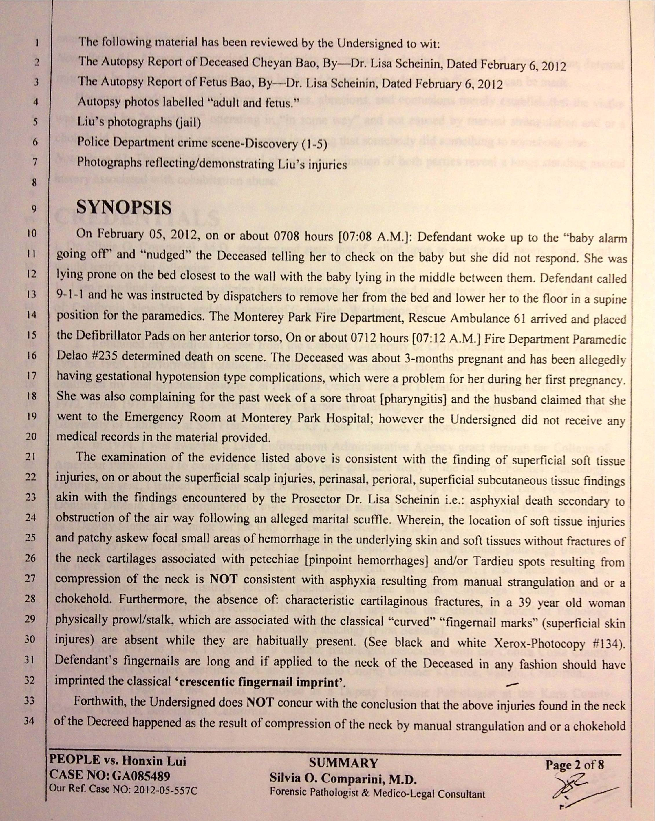
Dr. Comparini's qualification is on this page. 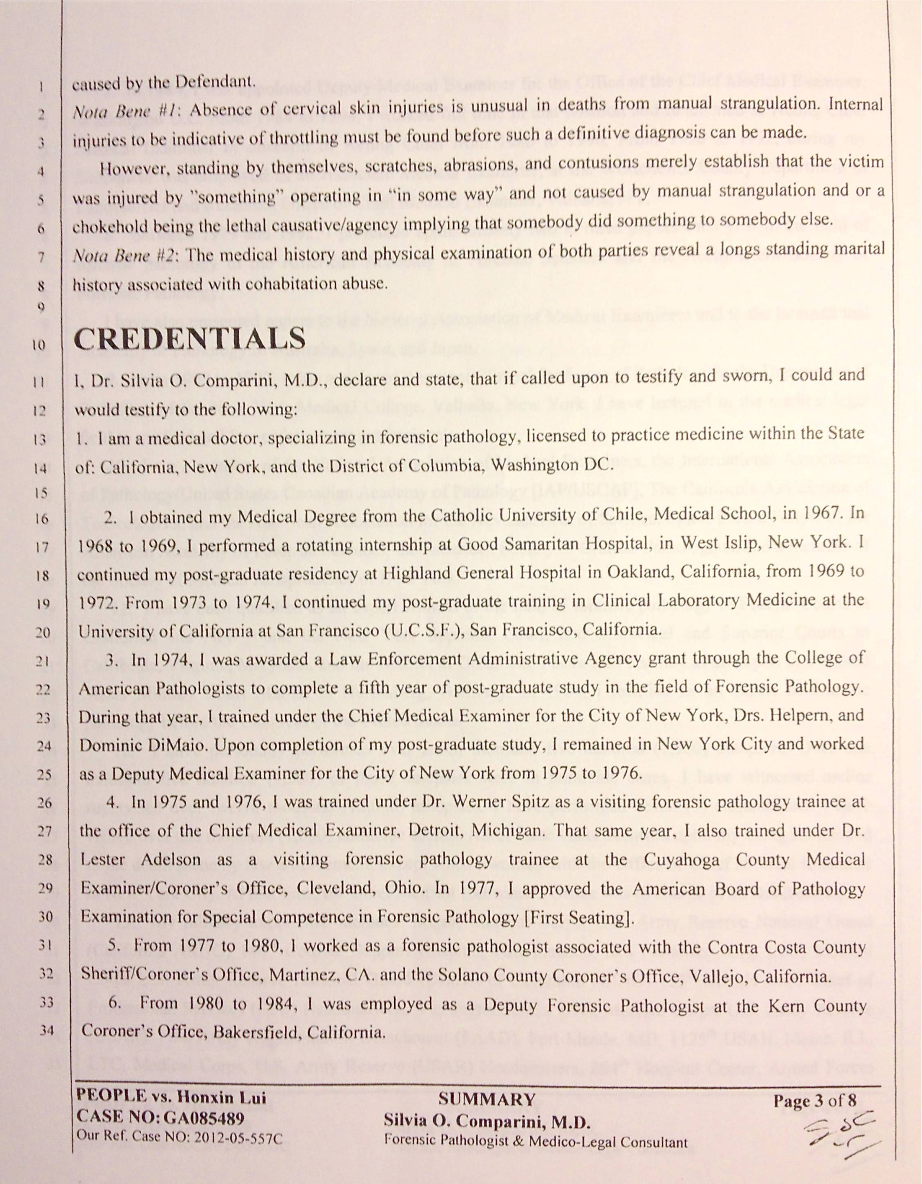
Hongxin's childhood has been happy and adorable. All his relatives and friends have testified Hongxin's impeccable character and behavior.
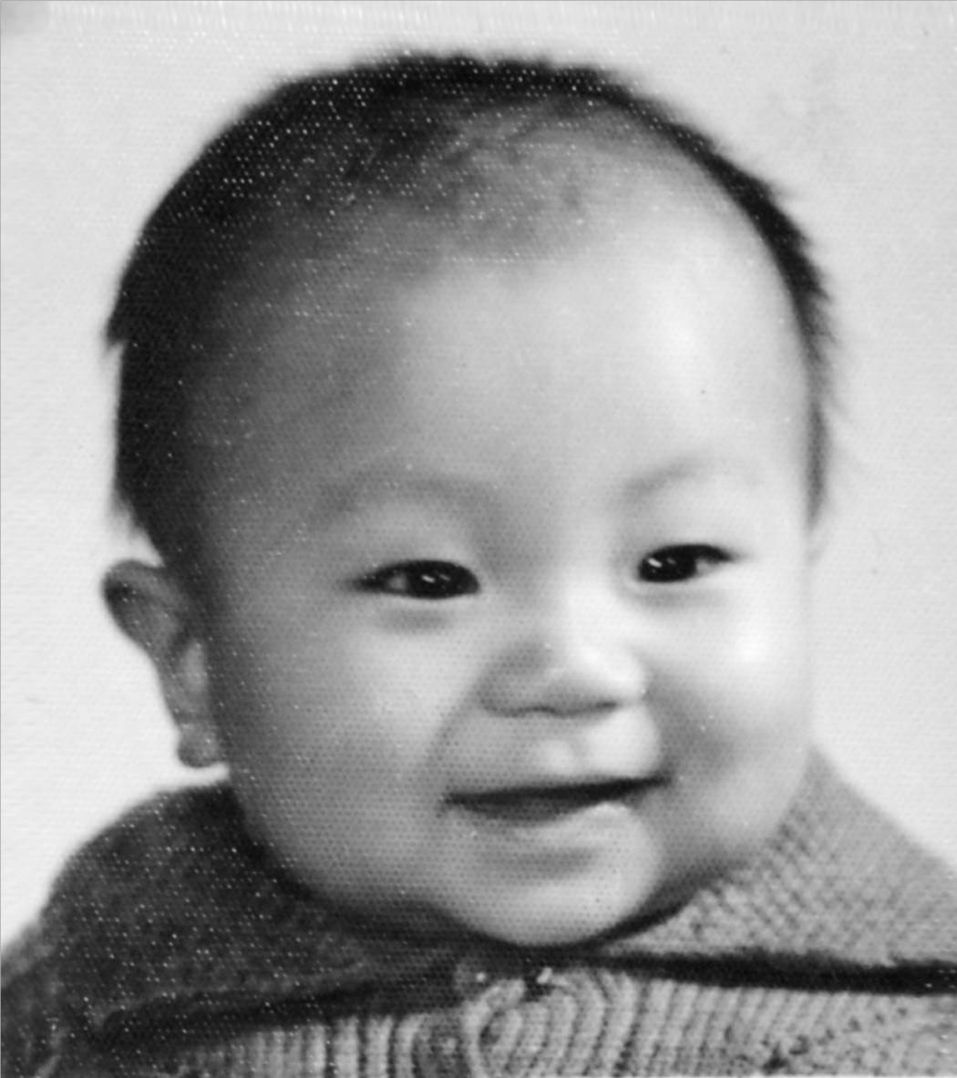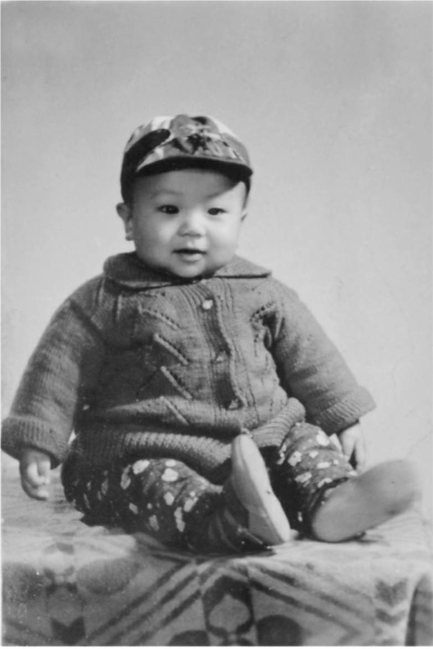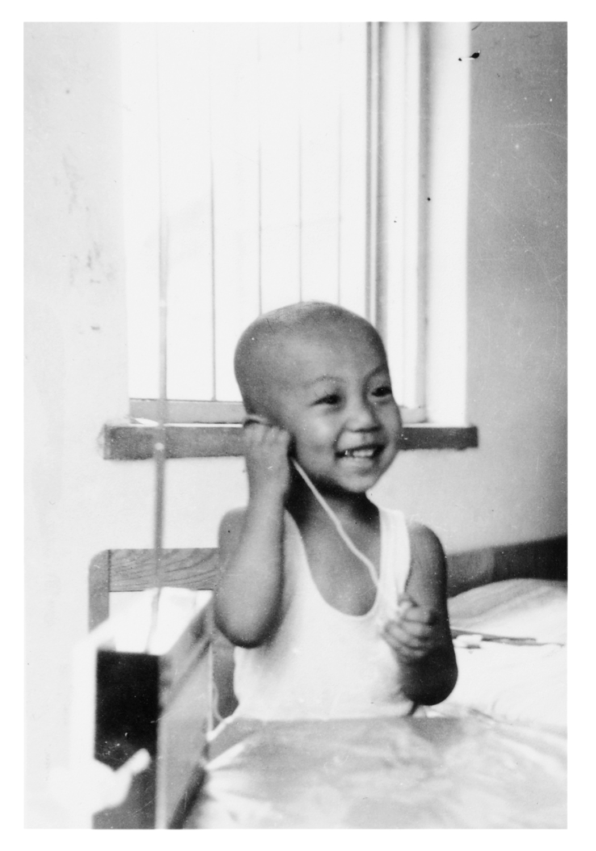
Hongxin's marriage has been perfect at first, but it lacked harmony. 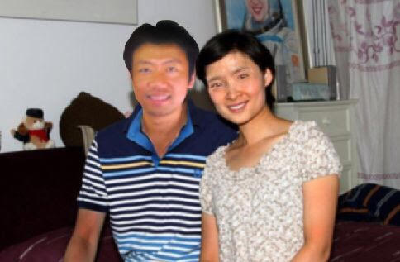
After the unhappy ending of his wife, Hongxin's mother came here trying to free him. His mother made a lot of sense. Please read her testimonies to the lawyer, Mr. Darden, Esq. as follows:
March 1, 2014
Dear Mr. Christopher Darden, Esq.,
Greetings to you in the Lord.
I am a Christian. I do not lie. My son's wife died of multiple sicknesses: She was pregnant with a boy for three months. She frequently felt chest discomfort. She also suffered from frequent dizziness. Her blood pressures were especially low. This had been verified by two hospitals. She was in her forties. After she flared up in temper, she went to bed. The next day something happened. My son called 911, but was too late. She was gone. His daughter was taken away. Disaster came. My son was also taken away. His daughter was less than two years old at the time. His daughter could not see her mom or even her dad. My son was heart-broken. He had lost control. He became crazy. He thinks that his wife is still here. He thinks that his daughter came back. My son has been miserable for the last 12 months.
The court suspects that: Because my son has long suffered from the abuse from his wife, at last he could bear no more, and he suffocated his wife using a pillow. I told them that they had been living peacefully. They loved each other. In China, before they were married, she already became pregnant with a daughter. They both came to the United States in December 2009. On April 28, 2010, a pretty girl was born to them. When his daughter was 19 months old, his wife again was pregnant in November 2011. They both said that in America, there is no control on having more children. They both agreed to have more children. Is this the reason why my son was jailed? What is the reason that my son killed his wife? They only met and knew each other for three years. During these three years, they had been in love and at peace with each other. Was it because the bad temper of his wife? This could not be the reason why my son killed his wife. After she vented her temper, she would calm down. She would apologize and my son forgave her. They were not antagonistic to each other.
The court thinks that his wife died; her womb also died. Therefore, my son has killed two lives. Is this fair and just? My son loves his wife and his daughter. The Liu family does not have a grandson. Having a boy as grandson is precious indeed. There is no reason why my son killed his wife.
With the above reasons, my son was wrongfully accused. His wife's death was due totally to an accident. Because of her low blood pressures, insufficient blood went to her brain. Therefore, she died. Please ask the court to consult some medical specialists, family violence experts, and psychiatrists to determine her actual cause of death. This is the only way to clear up some misunderstanding concerning her death.
My son has been heart-broken. His wife died. And, his daughter was taken away. Why? My son has not been convicted. His daughter was taken away. Please ask the judge to bring his daughter back. The death of my son's wife was due to multiple illnesses. If my son was released due to wrongful jailing, then who is responsible for his daughter. Please release my son.
1. Please arrange some medical specialists to determine the actual cause of the death of my son's wife, so that my son can be released.
2. Because of lack of evidence, my son was locked up. He has been beaten and humiliated. Why he cannot be released with a bail?
3. My son's wife has a son due to prior marriage. His name is Mr. Wang Cheng Hong, 23 years old, and has U.S. green card since 2012 here in America. Please contact him for some details about his mom.
4. The former husband of my son's wife is Mr. Zhuo Dong Hong. His phone number is 0511-6880081. Please find out from him about the health of my son's wife. The address in China is Pok Lin Enterprise in the city of Dan Yang.
5. Before my son's wife was cremated, why my son's permission was not consulted? The two doctors who performed autopsies on my son's wife were different. Why didn't ask another doctor to preview and perform another autopsy? But the actual evidence was already in ashes. Why? Why? No one informed my son that his wife was cremated. This is outrageous!
6. Is there any evidence that my son was being abused my his wife for a long time so my son suffocated his wife with a pillow?
7. Mr. Li Wei Wang, who lived at 1006 S. Ynez Ave., Monterey Park, was the landlord of my son's family for a while. His phone number is 909-333-8205. Please find out from him about my son's family conditions. That house was sold to someone else in 2013.

--------------------------------------------------------------------------------------------------
June 11, 2014
Dear Mr. Christopher Darden, Esq.,
Greetings to you in the Lord.
1. There are many witnesses who testified that my son is innocent. These witnesses show that Hongxin Liu is a victim. In fact, his wife was hot tempered. She liked to act up. After acting up, she went to bed. The next day, she was found not being well. Then my son dialed 911 and called the ambulance. This has been the facts. The most important is to find a good family specialist to testify on behalf of my son. It was not what my son did. She died suddenly because of her illnesses.
2. The fact is that my son was patient with his wife. On my son's belly, there was skin ulceration. If it was not that my son let his wife scratch his belly, then why my son's belly had scratch marks? Why the scratch marks on his belly were arranged in a straight fashion? It was because my son loved his wife dearly. After his wife flared up, his wife always confessed afterwards. She then became tender to my son.
3. Mr. Darden, please believe me. Hongxin Liu did not harm his wife in any way. The outside skin scratches on his wife were the result of her anger resulting in hitting herself accidentally.
4. The first lawyer, Mr. Perliss, advised my son to give the excuse of "self-defense" and "mistake." Up to now, we do not understand such defense would result in my son's innocence or guilt. My son is innocent. I am the mother of Hongxin Liu. I guarantee my son is innocent. I can swear to God that my son is innocent. My son did not harm his wife in any way, because our whole family wants his wife to bear a beautiful grandson. This not-yet-born baby was the only child to bear our family name.
5. Mr. Darden, please search for the physician that Mr. Perliss hired so that my son will be released. My son suffers greatly in jail. He loves his wife. His daughter was taken away by a stranger. I am sure you will find all means to show that my son is innocent. You are an excellent lawyer. You have love for your clients. God will certainly bless you. God will give you wisdom and strength to rescue Hongxin Liu from jail and to restore his innocence.
6. We have so far three public appointed lawyers who said they have been trying to find a good doctor to testify my son's innocence. To this day, this has not been accomplished. Therefore, my son and myself, and the whole church are praying to God for you to find such a medical doctor. We all know that you are full of love for your clients. You can rescue my son . In order to rescue my son, we sold our house. I also found such a responsible and powerful lawyer. After much prayer, the human rights lawyer introduced you, Mr. Christopher Darden. This is the will of God. I believe God will give you the power and authority. God will provide a medical doctor for us. God will also provide a team of capable jurors. Jesus will prevail. Mr. Darden will prevail. We pray in the Name of Jesus that Hongxin Liu will be released. Hallelujah! Amen!
----------------------------------------------------------------------------------------------------
For those who read Chinese, here is Hongxin's own testimony: 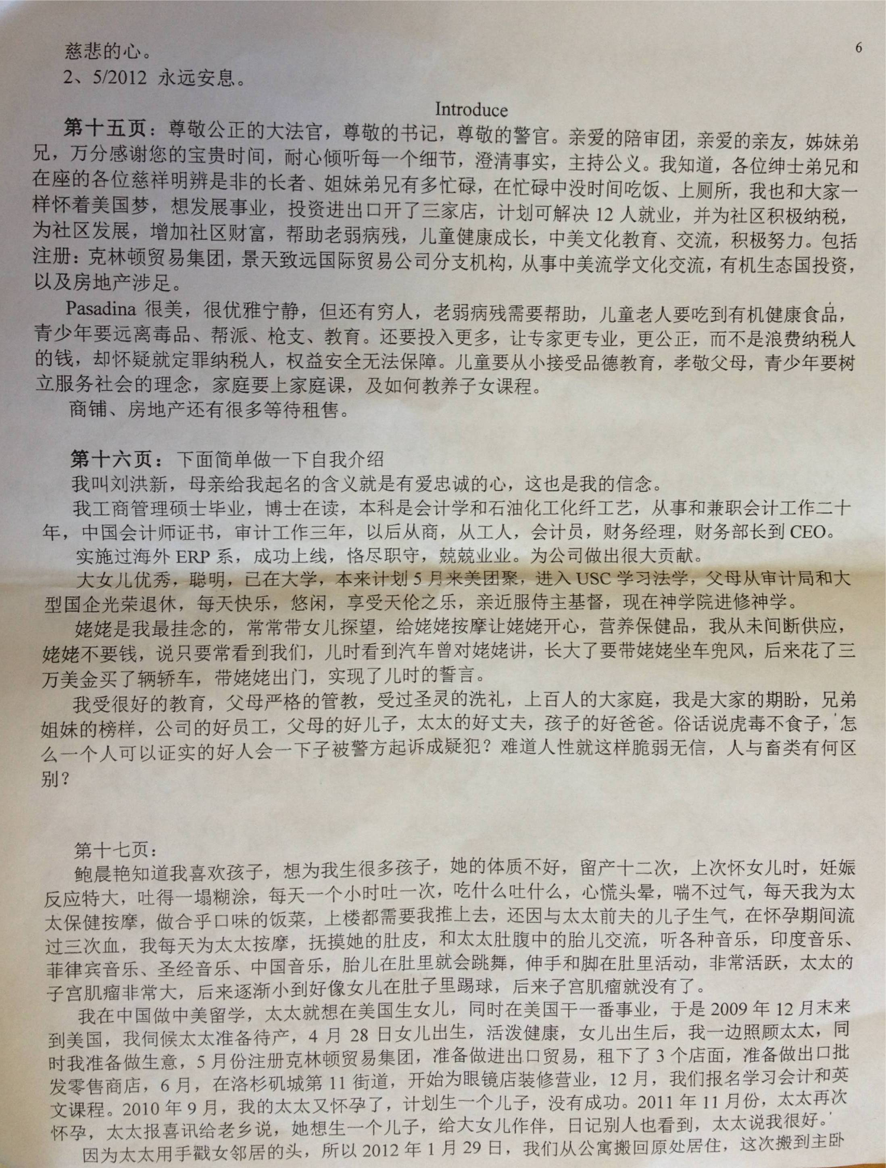 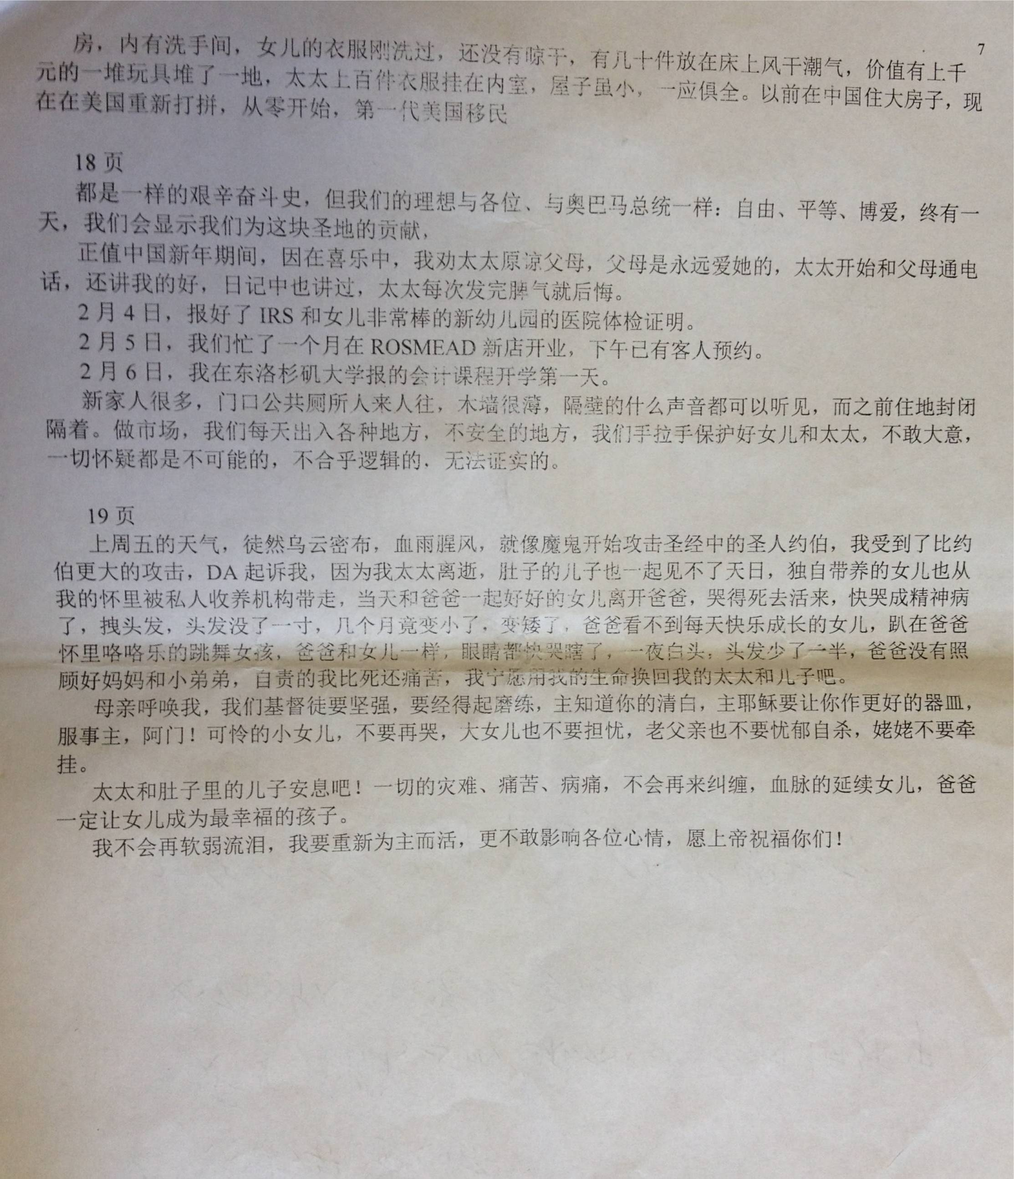
Please visit the website http://azenterprises.us. Please write a check payable to AZ Foundation, and send it to 3930-I Rosemead Blvd., Rosemead, CA 91770. A tax-deductable receipt will be sent to you. You may also donate using your credit card. Please visit Paypal and send an email to ckchui1@gmail.com. Specify your name and address. A tax-deductable receipt will be sent to you. May God bless you and your family in the years to come.
Now, Hongxin dreams about his wife and daughter as told by his mother as follows:
崔教授您好:
请您帮我把儿子做的梦告诉达顿律师，刘洪新的梦；只有在梦里与你相见，激动的泪水，湿透枕巾，哭着醒来找不见你，我有力拉车爬上农贸市场的斜坡，太太和女儿坐在车里吃水果，阳光明媚，我汗流夹背，看着女儿在太太怀里撒娇，我好开心，女儿有妈妈多有福，可我想到太太不是不在了吗，我就问太太，我以为你不在了，到底哪个是真的呢？不要再逼我了，你不在了是个梦，我们在一起，我和女儿不能没有你，太太看着我咧嘴笑，太太继续喂女儿水果，我为这幸福场面，大哭起来。这时集市大棚里，我躲到一边，继续哭，哭醒了，不知哪个是梦，哪个是真。希望梦不要再醒。 谢谢崔教授，圣诞节快乐

